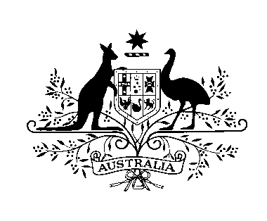

**AUSTRALIAN EMBASSY TIMOR-LESTE**

19 September 2018

**2019 AUSTRALIA AWARDEES CELEBRATE INCLUSIVITY**

We are delighted to announce the new intake of Australia Awards Scholars for 2019. Twenty talented men and women from across Timor-Leste were selected for a life-changing opportunity to study at a range of Australian Universities.

This year’s intake includes two awardees, Casmira do Rosario Maia and Antonio Castro da Costa who are living with a disability. Twenty-nine-year-old Casmira will study for a Masters in Disability Policy and Practice at Flinders University, whilst Antonio, 36, will study for a Bachelor’s in Community Development at Victoria University Melbourne.

*“When I heard I was so happy. I could hardly believe it as I only started learning English eight months ago and I knew the application process was very competitive. I want to use this opportunity to help change attitudes to people with a disability in my country. When people living with a disability are denied an education they are denied the chance to be independent*.” **Australia Awards Scholar 2019, Casmira do Rosario Maia said.**

Another first for the 2019 intake is that siblings Marito and Marilia da Silva Alves from Dili were successful. They will study Professional Engineering and Gender and Development respectively.

**Australian Ambassador, Peter Roberts OAM,** *said “Congratulations to the Australia Awards Intake 2019. We are so proud of the Australian Alumni who are contributing to the development of Timor-Leste in different ways. These 20 Timorese students now have a wonderful opportunity to expand their knowledge and skills at universities in Australia.”*

The 2019 Awardees will study at Masters’ level in subjects ranging from Applied Economics, to Health and Human Service Management and International Trade and Development. On graduation, they will bring back new research, approaches and knowledge supporting Timor-Leste’s economic, social and inclusive development.

Back home they will also join a cohort of more than 280 Australia Awards Alumni who are contributing to a brighter future in Timor- Leste and strengthening on-going links with Australia.

Congratulations go to;

ANTONIO CASTRO DA COSTA, Bachelor of Community Development, CASMIRA DO ROSARIO MAIA Master of Disability Policy and Practice, CRISTINA SARMENTO DA COSTA, Master of Health and Human Service Management, DAVIDA CRESCENCIA DE FATIMA MESQUITA, Master of International Trade and Development. ERKULANU DE SOUSA, Master of Community Planning and Development; ERMINIO BASILIO F. SEQUEIRA, Master of Education; FAVIANA BOSCO DE SOUSA, Master of Applied Economics and Econometrics; FELIX MAIA, Master of Development Studies; JEAN SIMOES DOS SANTOS, Master of Public Administration, JOANICO OLIVEIRA, Master of International Development, JOANINHA DA COSTA FREITAS, Master of Professional Engineering, LUISA GUSMAO DE GONZAGA, Master of Management ( Human Resource Management), MARCELINO JOSE CORREIA, Master of Arts in TESOL, MARILIA DA SILVA ALVES, Master of Development Studies (Gender and development), MARITO DA SILVA ALVES, Master of Professional Engineering, NICODEMOS DOS REIS PEREIRA, Master of Taxation, NILTON VICENTE, Master of Applied Statistics, TARCISIO MARIA AMARAL, Master of Public Health, THOMAS ALMEIDA BORGES, Master of Public Policy and Management, UMBELINA CARDOSO, Master of Education ( TESOL).

*Australian Embassy Media Liaison: 7723 0366*

